Pulmonary Exercise for Swing Bed

Pulmonary exercise is an educational and behavioral intervention to improve functional lung capacity and enhance quality of life in patient with chronic respiratory disorder. During the hospital stay a limited exercise program that is coordinated by the physician, nurse and respiratory therapist is initiated. Patients and families are educated about pulmonary conditions, pulmonary risk factors and proper pulmonary care upon release from the hospital. All patients must be referred by the physician treating the chronic respiratory disease.

Advantages of Pulmonary Exercise Program
Pulmonary rehabilitation offers many positive benefits, including:
- Relief of respiratory symptoms (shortness of breath, dyspnea and fatigue)
- Reducing the fear and anxiety associated with chronic pulmonary diseases
- Increasing exercise capacity, stamina and the ability to perform daily activities
- Promoting an increased awareness of pulmonary disease and its management
- Improving respiratory hygiene to reduce infections
- Enhancing quality of life
Indications for Exercise
- Severe COPD
- Asthma
- Cystic fibrosis
- Bronchiectasis
- Interstitial lung disease
- Lung cancer
- Neuromuscular disorders
- Sarcoidosis
- Lung transplantation
- Lung volume reduction surgery

Exercise
- Exercise improve how well your body uses oxygen
- Ease your symptoms and improve your breathing
- Strengthen your heart, improve circulation, and lower your blood pressure.
- Improve energy
- Improve sleep
- Reduce social isolation
Types of exercises
- Purse lip breathing
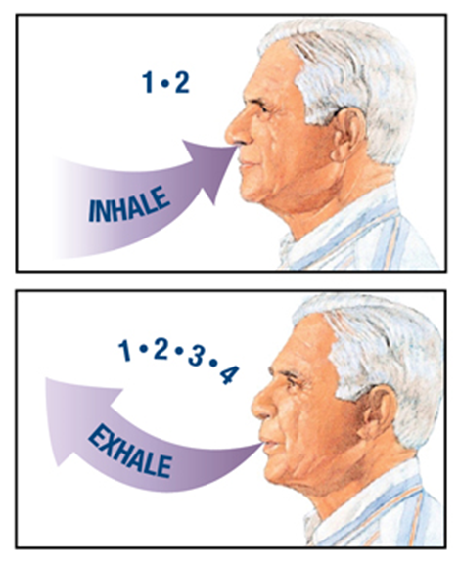
- Diaphragmatic breathing exercise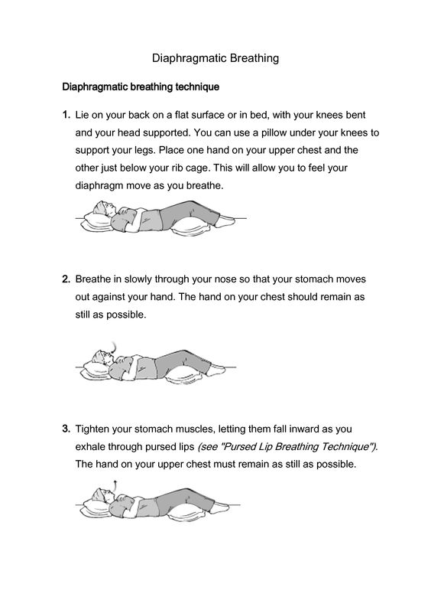

- 6 minute walk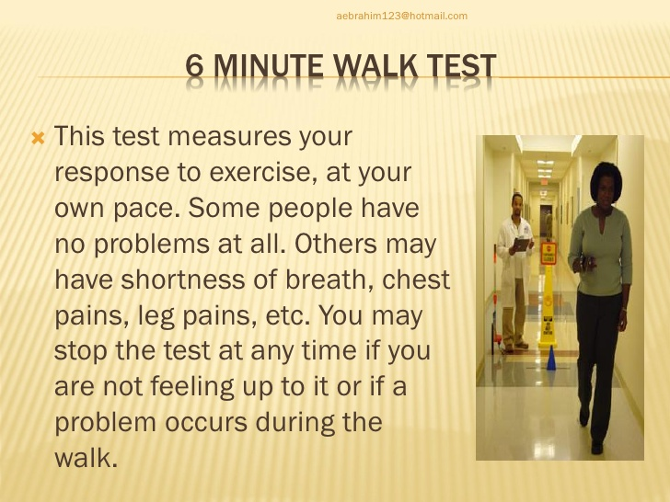
- Lung expansion maneuver (incentive spirometer) 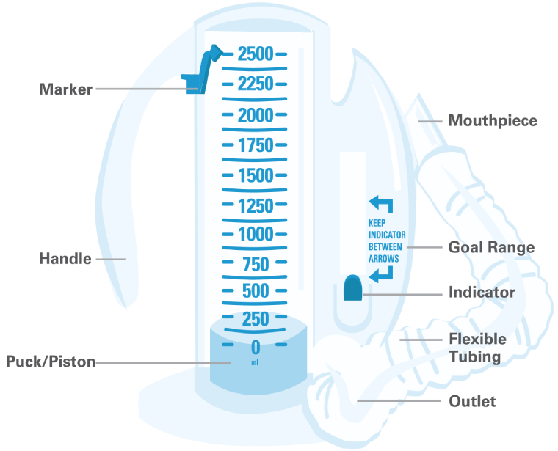

- Chest Physiotherapy (CPT)

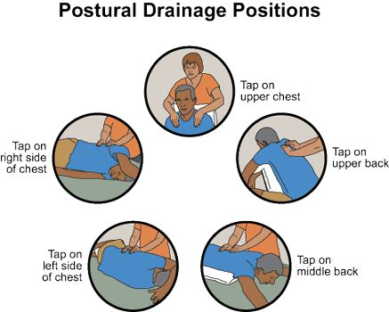
- PEP therapy (blowing through a mouthpiece against resistance).
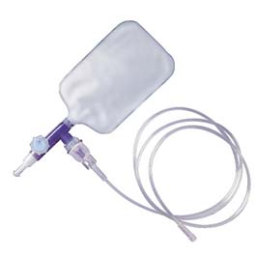

Educating the Patient
- Understanding your medication treatment plan (nebulizer meds, and inhaler med), and the proper way to use them.
- If the patient is a smoker, help with quitting if patient desire.
- Getting the most out of oxygen therapy.
Precautions
- You have a fever
- You have any shortness of breath or difficulty breathing while resting
- You have any chest pain or palpitations (fluttering of the heart in the chest)
- You have new swelling in the legs
STOP exercise immediately if you develop any of the following symptoms:
- Dizziness
- Shortness of breath more than normal
- Chest pain
- Cool, clammy skin
- Excessive fatigue
- Irregular heartbeat
Any symptoms you consider an emergency Call 911 immediately. If these symptoms don’t stop with rest or if you experience any change in mental status!

