McGehee Family Clinic Sliding Fee Schedule 2022
Discount Percentage 100% 67% 50% 25% 10% 0%
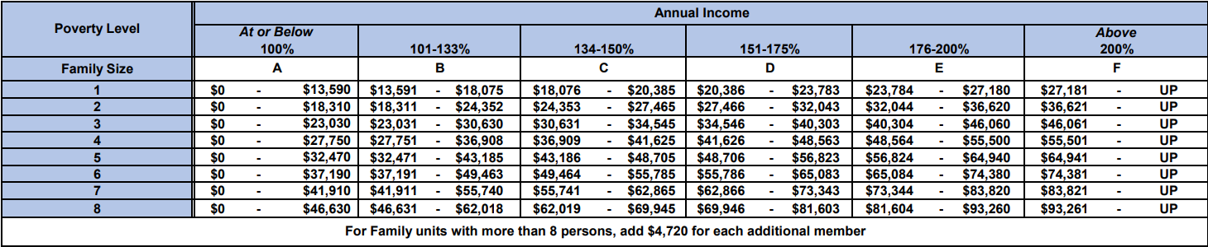

The nominal fee for patients that are at or below 100% of the Federal Poverty Guidelines will be $5.00 per visit.

